Forget-Me-Not:
Evaluating Machine Unlearning Under Tabular Data Deletion Scenarios

By
Niamh Hughes

A Research Paper
Submitted in Partial Fulfilment for the Degree of Master
in
Artificial Intelligence
Queen’s University Belfast
September 2026

Declaration of Academic Integrity

Before signing the declaration below please check that the submission:
- Has a full bibliography attached laid out according to the guidelines specified in the Student Project Handbook
- Contains full acknowledgement of all secondary sources used (paper-based and electronic)
- Does not exceed the specified page limit
- Is clearly presented and proof-read
- Is submitted on, or before, the specified or agreed due date. Late submissions will only be accepted in exceptional circumstances or where a deferment has been granted in advance.
- Software and files are submitted via Canvas.
I certify that that the submission is my own work, all sources are correctly attributed, and the contribution of any AI technologies is fully acknowledged.
I declare that I have read both the University and the School of Electronics, Electrical Engineering and Computer Science guidelines on plagiarism - https://www.qub.ac.uk/directorates/sgc/learning/LearningResources/Plagiarism/- and that the attached submission is my own original work. No part of it has been submitted for any other assignment and I have acknowledged in my notes and bibliography all written and electronic sources used.
I am aware of the disciplinary consequences of failing to abide and follow the School and Queen’s University Regulations on Plagiarism.

Name: (BLOCK CAPITALS) | NIAMH HUGHES
Student Number: | 40299386
Student’s signature |  | Date of submission

Forget-Me-Not: Evaluating Machine Unlearning Under Tabular Data Deletion

Niamh Hughes
School of Electronics, Electrical Engineering and Computer Science
Queen’s University Belfast
Belfast, United Kingdom
nhughes44@qub.ac.uk
Awais Rauf
School of Electronics, Electrical Engineering and Computer Science
Queen’s University Belfast
Belfast, United Kingdom
line 5: email address or ORCID
line 1: 3rd Given Name Surname
line 2: dept. name of organization (of Affiliation)
line 3: name of organization (of Affiliation)
line 4: City, Country
line 5: email address or ORCID
line 1: 4th Given Name Surname
line 2: dept. name of organization (of Affiliation)
line 3: name of organization (of Affiliation)
line 4: City, Country
line 5: email address or ORCI

Abstract—Being forgotten is not always about making information disappear. It is about ensuring that information no longer influences future decisions. This distinction is particularly important in machine learning, where deleting a record from a dataset does not remove the influence it may already have had on the trained model. Machine unlearning addresses this problem by attempting to remove the effect of selected training data without requiring the model to be rebuilt from scratch.
This study investigates whether approximate machine unlearning methods can provide an effective and efficient alternative to full retraining under realistic deletion requests. The evaluation moves beyond arbitrary deletion percentages by also considering structured scenarios representing different reasons and patterns through which training data may need to be withdrawn. Approximate unlearning methods are compared with full retraining across these scenarios, considering both the removal of forget-set influence and the preservation of model utility. The results demonstrate a general preservation of model utility, while forgetting performance varies across methods and deletion scenarios. Evaluating across deletion requests of different types and scales therefore provides a broader view of approximate unlearning performance than considering the amount of data removed alone.
Keywords—machine unlearning, right to be forgotten, data deletion, approximate unlearning, full retraining, deletion scenarios

Introduction
The Right to Be Forgotten (RTBF) has become increasingly important as organisations collect and use personal information in automated decision making within machine learning. Within the European Union, Article 17 of the General Data Protection Regulation (GDPR) establishes a Right to Erasure under specified circumstances [X]. More recently, Irish legislation has extended the terminology to cancer survivors, requiring qualifying cancer history to be disregarded when assessing mortgage protection insurance applications [X]. This reflects a wider development across Europe, where several countries have introduced similar protection for cancer survivors [X]. Although distinct from data erasure, these developments demonstrate the growing consideration being given to the continued use and influence of sensitive personal information in future decisions.
This issue presents a different technical challenge when information has already been used to train a machine learning model. Removing a record from the original dataset does not reverse the contribution it has already made to the trained model. Zhang et al. identify this as a challenge for applying the RTBF to learned models, where conventional approaches to data removal may not address information already incorporated during training [X]. This provides the main motivation for this project – if data must no longer be used, it is important to consider not only whether the original record has been deleted, but whether its influence remains within the model. Machine unlearning seeks to address this problem by removing the influence of selected training data from an existing model.
The most direct approach is Full Retraining, where the requested data is removed before the model is trained again using only the remaining data. This provides a useful reference for the behaviour expected after deletion, but repeating the complete training process for each request can introduce substantial computational cost. Approximate machine unlearning methods instead modify an existing trained model to reduce the influence of the selected data without rebuilding the model from scratch. This can reduce retraining time and computational requirements. Their effectiveness therefore depends on achieving sufficient forgetting without unnecessarily reducing the performance of the model.
Evaluating this trade-off requires consideration of both what has been forgotten, and what has been retained. Recent works such as TOFU and MUSE demonstrates the need to evaluate unlearning across multiple properties instead of relying on model utility alone [X], [X]. The conditions under which deletion occurs may also differ, as requests can vary in both the records they target, and the amount of training data affected. This motivates evaluating approximate unlearning across structured deletion scenarios of different types and scales, allowing its behaviour to be examined under a broader range of deletion conditions.
The aim of this study is to investigate whether approximate machine unlearning methods can provide an effective and computationally efficient alternative to Full Retraining across structured deletion requests. The objective is to compare the methods in terms of forgetting effectiveness, retained model utility, the effect of deletion size and computational efficiency. Retain-Set Fine-Tuning, Gradient Ascent and Gradient Difference are evaluated against Full Retraining using forgetting, retained utility, and computational cost. The study contributes an experimental evaluation in which deletion requests are defined by plausible reasons for data removal. A synthetic kidney- transplant dataset is used to represent structured deletion scenarios in a medical prediction setting, with an additional language-model experiment used to examine whether similar trends are observed in a different model setting. The primary scope focuses on tabular binary classification and the selected unlearning methods; the findings are therefore not intended to establish performance across other datasets, model architectures or additional unlearning methods.
The study addresses the following research questions:
RQ1: How do different machine unlearning methods compare in their ability to forget selected training data while preserving model utility?
RQ2: How does the size of the deletion request affect machine unlearning performance?
RQ3: What trade-offs exist between forgetting effectiveness, retained utility and computational efficiency across the unlearning methods?
RQ4: Are similar unlearning trends observed when the methods are applied to a language model?
To address these questions, structured deletion scenarios are used to create consistent forget and retain sets across the selected methods. The resulting models are compared using measures of forgetting effectiveness, retained model utility and computational efficiency. The remainder of the paper reviews the relevant literature, describes the methods and experimental design, presents the results and discussion, and concludes with the main findings, limitations and future work.

Literature Review
Motivation – In October 2026, the Right to Be Forgotten insurance law takes effect in Ireland. This law requires insurers to disregard cancer-related medical history in certain circumstances when a person applies for mortgage protection insurance [X]. This law raises a wider challenge for insurance companies using machine learning to predict these costs. Removing the original records does not remove the influence that they have already had on the model. This motivates the investigation and analysis of current approximate unlearning approaches to find one that achieves the most similar results to full retraining.
Zhang et al. (2023) [X] extends on this idea as he discusses the Google Spain case, where the RTBF was applied to the removal of links to personal information from search engine results. The paper considers how this idea has gotten more complex with the development of LLMs, as information may be learned through changing the model. This influenced the decision to include an element of LLMs in the research.
Approximate Unlearning – Full Retraining provides the gold standard approach to removing selected training data, as the model is rebuilt without the forget set. However, the computational cost and time spent makes this impractical. Previous research has investigated different approximate approaches that can instead update an existing trained model. Previous research has proposed several unlearning approaches to overcome this issue. Golatkar et al. [X] consider Fine-Tuning as a simple baseline, where fine tuning continues on the retain set to reduce the influence of the forget set. More recently, Maini et al. [X] evaluate Gradient Ascent and Gradient Difference within the TOFU framework. The TOFU framework was created through studying LLMs and question answering pairs but the approaches can also be applied outside of generative models. Gradient Ascent targets the forget set by increasing its loss, while Gradient Difference combines this with decreasing the loss on the retain set. These approaches allow comparison between approaches that focus on forgetting and preservation of retained information. However, improving forgetting alone may create the trade-off between removing the influence of the forget set and preserving useful model behaviour. The size of the forget-set may also affect this trade off. Golatkar et al [X] found that forgetting became more difficult as the forget cohort increased. This motivates the comparison of the trade-off between forgetting, model utility and computational efficiency across deletion requests of different sizes within this study.
Realistic Deletion Requests – The Irish RTBF legislation has influenced the setting used within this study. Structured information is commonly used for insurance pricing companies, providing motivation for investigating unlearning within a tabular classification setting. Additionally, the synthetic dataset allowed for deletion requests to arise from realistic circumstances such as an individual withdrawing their data rather than arbitrary percentages. Retention Expiry was particularly relevant to the Irish legislation example as it involved data being removed based of time periods. The resulting forget-sets therefore differed both in size and structure.
Evaluation – Previous research has highlighted the difficulty in measuring unlearning, as there is no single metrics to measure this. Maini et al. [X] address this within TOFU by using a two dimensional evaluation using forget quality and model utility. MUSE [X] takes this idea further by using a six-way evaluation framework, covering issues like scalability, sustainability and privacy leakage too. For this research, TOFU’s approach has been borrowed, as both metrics (forget quality and model utility) map better to tabular classification data than MUSE’s dimensions, which are instead more suited to language models. TOFU’s approach was taken one step further and adapted to add computational efficiency, resulting in a simple three dimensional evaluation approach to measure machine unlearning.
Research Gap – Existing work therefore provides established approaches for approximate unlearning and demonstrates the importance of evaluating both forgetting and retained utility. TOFU also shows the value pf controlled synthetic datasets and evaluating multiple forget-set sizes. However, there is less evidence on how these approaches behave when deletion sets are defined by structured reasons for data removal within a tabular medical prediction task. This study addresses this by comparing selected unlearning methods across structured deletion scenarios, deletion sizes, retained utility and computational efficiency, before examining whether similar trends are observed in a language model setting.

Methodology

Synthetic Kidney-Transplant Dataset
A synthetic dataset was chosen for the unlearning experiments, as the study involved sensitive medical and personal information. Using a synthetic dataset also allowed for greater control over the experimental design, including the information required to create the five deletion requests. The dataset represents kidney-transplant recipients through a series of post-transplant assessments that measure changes in clinical information over time. It also includes relationships between recipients, donors, and hospitals, and information about data consent and retention dates. These relationships allowed the deletion requests to target different groups of records. The dataset was therefore designed not only to support the medical prediction task, but also to provide a controlled setting in which different forms and sizes of data deletion could be investigated.
The dataset was generated using a hybrid Python-Qwen process through an API. Python was used to define the fixed structure of the dataset and the elements that needed to remain under experimental control. This included the assessment schedule, recipient, donor and hospital relationships, consent and retention information, numerical constraints and event schedules. Python was also used to derive the prediction target from the predefined rejection events.
Python populated a structured prompt template with recipient specific values before each API request. The completed prompt was then sent to Qwen, which generated longitudinal clinical measurements across the six assessments, including creatinine, urine output, tacrolimus level and medication adherence. The model was instructed to begin from Python-generated day-7 numerical anchors and to generate the remaining assessments as a coherent clinical trajectory while following the supplied recovery, rejection, infection, adherence, tacrolimus and confounder controls. This allowed variation to be introduced between recipient trajectories while keeping the experimental structure and target definition under deterministic control.
- Qwen prompting Strategy for Datset Generation
Qwen Prompting Strategy for Dataset Generation
Recipient seed: { }
Baseline creatinine: { }
Recovery pattern: { }
Rejection event schedule: { }
Rejection signal strength: { }
Infection episode days: { }
Medication adherence pattern: { }
Tacrolimus exposure pattern: { }
Non-rejection confounder: { }

Day-7 numerical anchors generated in Python:
Creatinine: { } mg/dL
Urine output: { } mL/24h
Tacrolimus: { } ng/mL
Medication adherence: { } %

Use values close to the supplied day-7 anchors and construct the remaining five assessments as a coherent clinical trajectory. Follow the supplied recovery, rejection, infection, adherence, tacrolimus and confounder controls. Use recipient-specific numerical values rather than a default trajectory and keep all values within the approved ranges.

Return six assessments at days 7, 14, 30, 60, 90 and 180 containing only:
days_since_transplant
creatinine_mg_dl
urine_output_ml_24h
tacrolimus_level_ng_ml
medication_adherence_pct

ª The placeholders were populated with recipient specific values in Python before the prompt was sent to Qwen.
Before the dataset was used in the experiments, automated validation checks were applied to confirm that the generated data followed the required structure and constraints. These checks verified that each recipient contained six assessments at the expected time points, that clinical values remained within the approved ranges, and that the day-7 values remained sufficiently close to the Python-generated anchors. Additional checks were used to identify missing values, duplicate records and inconsistencies in recipient-level information. This ensured that the Qwen-generated values remained consistent with the predefined experimental design.
The final dataset contained 10,000 recipients, with each recipient represented by six post-transplant assessments, producing 60,000 assessment records. Assessments were recorded at 7, 14, 30, 60, 90 and 180 days after transplantation. The dataset contained a combination of recipient and donor information, longitudinal clinical measurements, assessment metadata and fields relating to consent and data retention.

Prediction task and Baseline model
The task was formulated as a binary classification problem, predicting whether a kidney-transplant recipient would experience acute rejection within 30 days of the current assessment. Each record represents one post-transplant assessment, with the model using the clinical information available at that point to make a prediction. The input features include measurements such as creatinine and tacrolimus that change across the recipients’ assessments. The target was imbalanced, with the positive class forming only 7.49% of the assessment records (4,494 of 60,000). This imbalance was considered when developing and evaluating the classifier.
A Multi-Layer Perceptron (MLP) was selected as the baseline classification model. An MLP was suitable for the structured tabular data and binary prediction task, while also providing direct access to the model loss and gradients required by the gradient-based unlearning methods. The model architecture was deliberately kept small and not optimised to maximise prediction performance, as the aim of the study was not to get the predictive performance, but instead to compare the behaviour of the unlearning methods. The same model architecture was therefore maintained across the Baseline, Full Retraining and all approximate unlearning experiments.
After preprocessing, the model received 24 input features. The MLP contained two hidden layers of 64 and 32 units, each using ReLU activation followed by 10% dropout, before a single-logit output layer. This produced a total of 3,713 trainable parameters. A separate sigmoid layer was not required because binary cross-entropy with logits was used during training.
The Baseline model was trained prior to deletion request applications. The data was split into training, validation and test sets using a 70/15/15 split, containing 42,024, 9,988 and 8,988 assessment records respectively. The split was constructed so that there was no overlap in recipients, donors or assessment records between the three sets, preventing related records from appearing across training and evaluation data.
Numerical features were standardised and categorical features were one-hot encoded. The 18 selected input features produced 24 processed model inputs after preprocessing. Fields that were not intended for prediction were excluded from model training.

Forget and Retain Sets
Five deletion scenarios were defined to represent reasons why training data may need to be removed. As the dataset was synthetically constructed, the attributes used to define these scenarios could be controlled during dataset design, allowing forget sets of different sizes to be created. For each scenario, records meeting the specified deletion condition formed the forget set, while remaining training records formed the retain sets (Table 1). The same forget and retain sets were then used across all unlearning methods to ensure a consistent comparison.
- Deletion Scenarios
Scenario | Deletion Condition | Records Removed | Removed (%)
Recipient Withdrawal | Recipient withdraws consent | 426 | 1.01%
Donor Withdrawal | Donor withdraws consent | 1,992 | 4.74%
Hospital Withdrawal | Hospital data removed | 4,314 | 10.27%
Invalid Consent | Records identified with invalid consent | 4,148 | 9.87%
Retention Expiry | Records exceeding retention period | 6,262 | 14.90%

Machine Unlearning methods
Full Retraining and three approximate unlearning methods were evaluated using the same scenario-specific forget and retain sets. For each deletion scenario, the approximate methods began from copies of the same trained Baseline model, while Full Retraining used a newly initialised model trained only on the retain set. Full Retraining therefore acted as the reference for the behaviour expected if the forget-set records had not been used during training.
Full Retraining – A new MLP model was initialised from scratch and trained using only the retain set. The same model architecture and training procedure were maintained across deletion scenarios, producing a Full Retraining reference model for each request. As the forget sets were excluded completely from training, this provided the gold-standard reference against which the approximate methods were compared.
Retain-Set Fine-Tuning – Retain-Set Fine-Tuning began from a copy of the Baseline model. The forget-set records were then removed from the training data and training was continued using only the retain set. This method attempts to reduce the influence of the forget set by reinforcing performance on the information that should remain. Model performance was monitored using the retained validation set, and the checkpoint with the lowest retained-validation weighted binary cross-entropy was selected.
Gradient Ascent – Gradient Ascent began from a copy of the Baseline model and directly targeted the forget set. The loss was calculated on forget-set records and the model parameters were updated to increase this loss, with the aim of reducing the model’s performance on the data selected for removal. As increasing the forget-set loss could also reduce performance on retained data, the retained validation set was monitored through unlearning. Validation loss was allowed to increase by a maximum of 5% relative to the Baseline, and the checkpoint achieving the strongest forgetting within this constraint was selected.
Gradient Difference – Gradient Difference began from a copy of the Baseline model and extended the Gradient Ascent approach by considering both the forget and retain sets during optimisation. The method increased the loss on the forget set while simultaneously reducing the loss on the retain set, allowing forgetting and retained performance to be optimised together. The combined objective was defined as:

$$L_{\left(\text{diff}\right)} =-L\left(S_{F},w\right)+L\left(S_{R},w\right)$$

Where $S_{F}$ is the forget set, $S_{R}$ is the retain set and $w$ represents the model weights, and $L\left(S,w\right)$ represents the loss calculated over the corresponding set.

Experimental Pipeline
The same experimental pipeline was followed for all five deletion scenarios. The baseline model was trained using the full training set prior to deletion. For each scenario, the training set was split into the defined forget and retain sets. Full Retraining then produced a new scenario-specific reference model using only the retain set, while each approximate method began from a copy of the same Baseline model and applied its respective unlearning procedure. The resulting models were compared with the corresponding Full Retraining reference for that scenario. This process was repeated across all five scenarios while keeping the original data splits, Baseline model and evaluating procedure consistent.
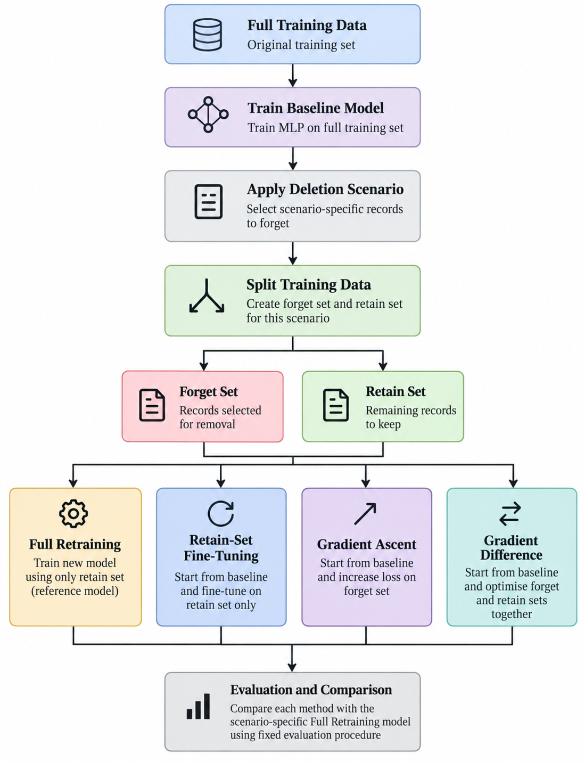Fig. 1. Experimental pipeline for the classifier unlearning study

LLMs – REVIEW AT END - UNFINISHED
An LLM was used to experiment on as an extension to the main study. The same pipeline was used, but instead of training and retraining using an MLP, LLM as a classifier was used to investigate whether the prediction task could be performed using a language model.
Qwen3.5-2B-Base was adapted as a binary classifier using Low-Rank Adaptation (LoRA), allowing the model to be fine-tuned using a smallser number of the parameters. Unsloth was used to reduce the memory and computational requirements of fine tuning. Training was performed using an NVIDIA A100-SXM4 80GB GPU through RunPod. This provided additional computational resources. All of these made training the model substantially faster.
Each assessment was converted from its tabular format into a serialized text input and tokensied before being given to Qwen. Cross entropy loss was used to train the model for this classification task. The model’s original output layer was replaced with a two-output classification layer representing no acute rejection withing 30 days (class 0) and acute rejection within 30 days (class 1).

Results and Discussion

Evaluation Framework

Forgetting Effectiveness
Forgetting effectiveness was measured by how closely each approximate method reproduced the behaviour of the corresponding Full Retraining model on the forget set.
Truth Ratio – TOFU [X] used Truth Ratio to measure how strongly an LLM preferred the correct answer over incorrect answers. This study adapted the same principle for binary classification by comparing the probability assigned to the incorrect class with the probability assigned to the correct class, using the equation:

$$R_{\left(truth\right)}=\frac{1-p_{\left(true\right)}}{p_{\left(true\right)}+ϵ}$$

Where:
- $p_{\left(true\right)}$ = probability the model gives to the correct class
- $1-p_{\left(true\right)}$ = probability it gives to the incorrect class
- $ϵ$ = very small value to avoid dividing by zero
A Truth Ratio was calculated for every record in the forget set, giving a distribution for each model.
Two-Sample KS Test – Still following TOFU’s evaluation [X], the two-sample Kolmogorov-Smirnov (KS) test was used to compare the Truth Ratio distributions of each approximate method with the corresponding Full Retraining reference distribution. The KS statistic measures the largest difference between the two distributions:

$$D=\sup_{x}\left|F_{A}\left(x\right)-F_{R}\left(x\right)\right|$$

Where:
- $F_{A}\left(x\right)$ represents the empirical Truth Ratio distribution of the approximate model
- $F_{R}\left(x\right)$ represents the corresponding Full Retraining distribution, and
- $D$ is the KS statistic

A value of D closer to 0 indicates greater similarity between the two distributions.
The Truth Ratio and KS test were used in conjunction to evaluate forgetting effectiveness. Truth Ratio represented model behaviour across the forget set, while the KS test measured how closely this distribution matched Full Retraining. The KS statistic was used as the main measure of distributional similarity, with the p-value used as supporting evidence of whether a statistically detectable difference remained between the distributions.

Retained Model Utility
Retained model utility was measured to ensure that the act of forgetting did not come at the cost of the model’s predictive performance. Multiple classification metrics were used as no single metric captures all aspects of performance, especially given the class imbalance within the dataset.
- Retained Model Utility Metrics
Metric | What it measures
PR-AUC | How well the model identified the less common positive cases
Balanced Accuracy | How well the model predicts both classes, giving each equal importance
F1-score | Balance between precision and recall
AUROC | How well the model separates positive cases from negative cases
Binary Cross-Entropy (BCE) | How close the model’s predicted probabilities are to the correct outcomes
Composite Utility | Overall model performance by combining utility metrics into one score
Composite Utility was calculated as the safeguarded harmonic mean of these metrics, where BCE quality was defined as $e^{-BCE}$. This provided a single higher-is-better summary of retained predictive performance.

Computational Efficiency
Computational efficiency was measured using the runtime required for each unlearning method. Each deletion scenario was compared with the runtime of the corresponding Full Retraining model and used to calculate the relative speed up. This allowed the computational savings of approximate unlearning to be considered alongside forgetting effectiveness and retained model utility.

Overall Unlearning Performance
The three approximate unlearning methods were compared across forgetting effectiveness and retained model utility, using Full Retraining as a reference each time. Forgetting effectiveness was represented by the KS statistic, where lower values mean greater similarity, and Composite Utility summarised retained predictive performance. Overall, retained utility was broadly preserved across all three methods, with greater variation shown in forgetting performance.
Across the three methods, Gradient Ascent achieved the strongest mean forgetting result, with the lowest mean KS statistic of 0.0428. Fine-Tuning produced a similar statistic of 0.0444, while Gradient Difference produced the highest mean KS statistic at 0.0509. Retained utility varied less between unlearning methods, with Gradient Difference, Fine-Tuning and Gradient Ascent achieving mean Composite Utility scores of 0.3404, 0.3381 and 0.3375 respectively.
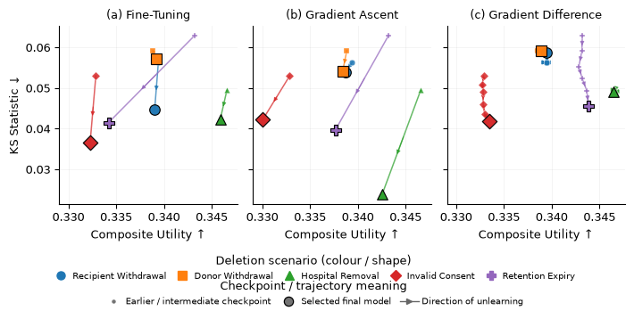
- Unlearning trajectories for Retain-Set Fine-Tuning, Gradient Ascent, and Gradient Difference, comparing Forgetting (Y axis) and utility (X axis).
Figure 1 compares the three methods’ trajectories in the forgetting-utility space. Gradient Ascent shows the widest spread, driven by an outlier and indicating greater variation between deletion scenarios. Fine-tuning shows a moderate distribution, with utility gains accompanied by variation in forgetting effectiveness. Gradient Difference produces the tightest cluster achieving the most consistent utility retention but does not show a clear improvement in forgetting.
Overall, Gradient Difference produces the most consistent trade-off behaviour across the scenarios, while Gradient Ascent achieved the strongest mean forgetting result.

Performance across Deletion Scenarios
The performance of all methods was compared against the five deletion scenarios, reviewing their effectiveness. The scenarios varied in size ranges from approximately 1% - 15% of the training data.
As shown in Fig. 2, forgetting effectiveness differed across the deletion scenarios. Gradient Ascent showed the greatest variation, with its lowest KS statistic of 0.0239 for Hospital Removal, compared with values about 0.05 in some other scenarios. The other approximate methods also varied between scenarios, showing that the effectiveness of unlearning was not consistent across deletion requests.
There was no consistent relationship between forgetting effectiveness and forget set size. This was particularly noticeable when comparing Hospital Removal and Invalid Consent, which both removed approximately 10% of the training records. Despite similarity in size, the two scenarios did not produce the same forgetting behaviour across unlearning methods. This suggests that deletion size alone was not sufficient to explain the observed differences in unlearning performance.
Retained utility was more consistent across scenarios. Methods formed a tighter cluster for Donor Withdrawal, while greater differences were observed for Retention Expiry.
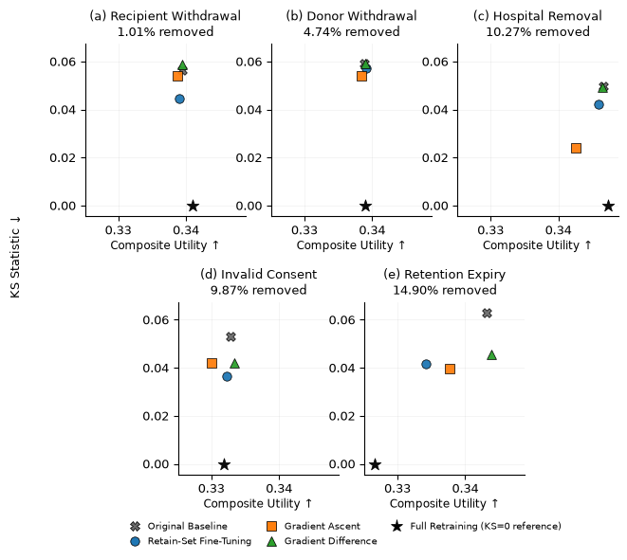
- Unlearning performance across the five deletion scenarios. Each graph compares the Original Baseline, Fine-Tuning, Gradient Ascent, and Gradient Difference against the scenarios Full Retraining. KS was 0 across all full retraining scenarios.

Computational efficiency
Computational efficiency was evaluated by comparing the runtime of each approximate unlearning methods with the corresponding scenario-specific Full Retraining runtime. All three approximate methods were faster than Full Retraining across the deletion scenarios.
Fine-Tuning provided the smallest improvement, with a mean speed-up of 2.32x compared with Full Retraining. Gradient Ascent showed a considerably greater mean speed-up of 12.08x, while Gradient Difference was the fastest method overall, with a mean speed-up of 28.86x.
- Computational Efficiency

Method | Mean Runtime (s) | Mean Speed-up
Full Retraining | 3.56 | 1.00x
Fine-Tuning | 1.53 | 2.32x
Gradient Ascent | 0.29 | 12.08x
Gradient Difference | 0.12 | 28.86x

LLM Results
1. MLP vs LLM classification
Table – MLP vs qwen classifcaition performance
2. unlearning results
Fig. llm unlearning performance

Discussion

Comparison of Unlearning Methods – RQ1
The results show that the approximate unlearning methods do not behave equally across the different evaluation dimensions. Gradient Ascent produced the strongest forgetting result overall, while Gradient Different preserved retained utility most consistently. Fine-Tuning remained competitive in both areas but did not clearly dominate either. This suggests that the optimisation objective of each method influences which aspect of unlearning it performs most strongly.
A similar point is made in TOFU, where methods that make use of the retain set are shown to behave differently from those that optimise only against the forget set. TOFU also highlights the importance of considering multiple evaluation measures, as improvement in forgetting foes not necessarily correspond to preserved model utility.
For this study, the main conclusion is therefore that there was no single approximate method that was strongest in every respect. Gradient Ascent gave the closest overall match to Full Retraining on the forget set, while Gradient Difference gave the strongest retained utility. The choice between methods therefore depends on which aspect of unlearning is prioritised.

Influence of Deletion Request Size – RQ2
The results did not show a consistent relationship between the size of the forget set and unlearning performance. Larger deletion requests did not automatically produce poorer forgetting, and smaller request were not always easier to remove. This suggest that forget-set size alone does not determine how difficult a deletion request is for an approximate unlearning method.
This was particularly clear for Hopsital Removal and Invalid Consent. Although both removed approximately 10% of the training data, they produced different forgetting behaviour across the methods. The records selected by each scenario therefore appear to matter alongside the number of records removed. However, because the size and composition of the forget sets changed together, their individual effects cannot be separated within these experiments.
The findings therefore suggest that evaluating unlearning only at different deletion percentages may give an incomplete view of performance. Testing multiple realistic deletion conditions provides a broader indication of how approximate methods may behave when deletion requests affect different groups of training records.

Practical Trade-offs and Implications – RQ3
The results show that the practical value of an approximate unlearning method depends on more than its forgetting performance alone. A method that forgets strongly may be unsuitable if it damages the remaining model, while preserving utility is not sufficient if the deleted data continues to influence the model. Computational efficiency adds a further consideration, since a faster method is only useful if it also provides acceptable forgetting and retained performance.The three methods therefore represent different trade-offs. Gradient Ascent produced the strongest forgetting overall, while Gradient Difference provided the greatest computational saving and strongest retained utility. Fine-Tuning offered a more moderate balance between these areas. This reinforces the need to evaluate unlearning across several dimensions rather than selecting a method using a single metric.
These trade-offs are important in practice because organisations may receive deletion requests affecting different quantities and groups of training data. The results suggest that performance under one deletion condition should not automatically be assumed to generalise to another. In a Right to be Forgotten setting, the objective is therefore not simply to remove the original record, but to reduce its learned influence while maintaining useful model behaviour at a reasonable computational cost.

Language-Model Extension – RQ4

Interpretation of the findings
The results demonstrate that generally, approximate unlearning can retain the utility of models and bring down the computational cost required to retrain from scratch. However, these methods did not always reproduce the behaviour of Full Retraining. There remained differences in forgetting effectiveness throughout all methods.
When forgetting effectiveness was considered alone, Gradien Ascent performed the strongest overall, achieving the lowest mean KS statistic. When utility alone was considered, Gradient Difference performed the most like the Full Retraining, and had the highest computational speed up. Therefore, there was no single method that performed strongest across all three measures.
This highlights the importance of evaluating unlearning across the three chosen dimensions, as methods considered strongest differ depending on the objective being prioiritised. This aligns with the approaches used in TOFU [X] and MUSE [X] , where successful unlearning is evaluated across multiple metrics and not just forgetting alone.

Influecne of deletion request
Despite forget set size having an effect on forgetting performance, it was not enough to see a clear correlation between the two. For example, Hospital Removal and Invalid consent each removed approximately 10% of the data but produced notecably different results.
This supports investigation of unlearning across deletion requests with different characteristics, rather than forget set size alone. The results demonstrate that evaluating different types of deletion requests can provide a broader view of approximate unlearning performance than evaluation based only on the amount of data removed.

Practical implications
The choice of an approximate unlearning model may thus depend on the requirements of the deletion request. A method offering strong forgetting may be unsuitable if it damages the remaining model, and preserving the models performance may result in data that has a lesser impact in results but has not been sufficiently forgotten.

irish RTBF – can we add this in more
Legialstion illustrates why info that WAS available may later need to stop influencing a decision

Final Considerations

Conclusion
The results show that the approximate unlearning methods offered different strengths rather than one method performing best across every measure. Gradient Ascent achieved the strongest forgetting result overall, producing the lowest mean KS statistic, while Gradient Difference achieved the highest retained Composite Utility and the greatest computational speed-up. Fine-Tuning remained competitive but provided smaller computational savings. The findings therefore show that the relative performance of an unlearning method depends on which aspect of unlearning is prioritised.
The experiments also did not show a consistent relationship between forget-set size and unlearning performance. Deletion scenarios of similar sizes could produce different forgetting behaviour, while larger deletion requests were not consistently more difficult to unlearn. This suggests that deletion size alone is not sufficient to explain unlearning performance and that the records included within a deletion request may also influence the result.
Overall, approximate unlearning provided substantial computational savings while broadly preserving retained model utility, but it did not consistently reproduce the behaviour of Full Retraining. The results therefore support evaluating machine unlearning as a trade-off between forgetting effectiveness, retained utility and computational efficiency rather than relying on a single measure of success. [A final sentence addressing the LLM research question will be added following completion of the LLM experiments.]

Limitations and Challenges
The findings should be interpreted within the controlled experimental setting used in this study. The dataset was synthetically generated and the main experiments used a single dataset and MLP architecture. While this allowed the deletion scenarios to be designed and controlled, it also limits how confidently the findings can be generalised to real clinical datasets, other application domains or different model architectures. The experiments were also conducted using a single fixed seed, meaning that variation between repeated training runs was not measured.
A further limitation is that the size and composition of the forget sets changed together. This means that differences between deletion scenarios cannot be attributed independently to the number of records removed or to the characteristics of those records. Although the results suggest that deletion size alone does not explain performance, the experimental design cannot determine exactly which properties of a deletion request caused the observed differences.
Forgetting was evaluated using Truth Ratio distributions and the KS test against Full Retraining. These measures provide evidence of how closely an approximate model behaves compared with a model that was never trained on the deleted records, but they do not prove that all influence of the forgotten information has been completely erased. Runtime results are also specific to the hardware and software environment used in the experiments and should therefore be interpreted comparatively rather than as universal execution times. Finally, the LLM extension was narrower in scope than the main classifier experiment, so any conclusions about whether the same behaviour generalises to language models should be treated cautiously.

Future Work
Future work could separate the effects of deletion size and forget-set composition more directly. Experiments could compare deletion requests of the same size but different compositions, followed by experiments using the same type of deletion request at several different sizes. This would make it possible to investigate whether one of these factors has a stronger influence on unlearning performance.
The robustness and generalisability of the findings could also be tested using multiple random seeds, additional datasets and different model architectures. Privacy-focused evaluation methods, such as membership inference attacks, could complement the Truth Ratio and KS evaluation and provide further evidence about whether information remains detectable after unlearning.
Further experiments could also examine sequential deletion requests, where models receive multiple requests over time rather than each deletion being evaluated independently. The LLM work could be extended from classification to direct generative unlearning, allowing the methods to be evaluated in a setting closer to TOFU. A further synthetic experiment based specifically on insurance decision-making could also provide a closer connection to the Right to be Forgotten motivation used in this study.

AI Ethical Considerations
Synthetic medical date was used to avoid exposing real patient information during the experiments. Real health and transplant data would contain highly sensitive personal and medical information and would require substantial privacy, governance and access controls. The use of synthetic data therefore allowed the prediction and unlearning experiments to be developed without placing real individuals' information at risk. However, synthetic medical data should not be assumed to represent the full complexity or distribution of real clinical populations.
The project was motivated by privacy and the Right to be Forgotten, making responsible interpretation of the unlearning results particularly important. The approximate methods were evaluated by comparing their behaviour with Full Retraining, but the evaluation does not establish a guarantee that information has been completely erased from a model. It would therefore be inappropriate to present approximate unlearning as proof of compliance with a deletion request based on these experiments alone. In practical applications, technical unlearning results would need to be considered alongside privacy testing, governance processes and applicable legal requirements.

Acknowledgment (Heading 5)
I would firstly like to thank my supervisor, Awais

References
- G. Eason, B. Noble, and I. N. Sneddon, “On certain integrals of Lipschitz-Hankel type involving products of Bessel functions,” Phil. Trans. Roy. Soc. London, vol. A247, pp. 529–551, April 1955. (references)
- J. Clerk Maxwell, A Treatise on Electricity and Magnetism, 3rd ed., vol. 2. Oxford: Clarendon, 1892, pp.68–73.
- I. S. Jacobs and C. P. Bean, “Fine particles, thin films and exchange anisotropy,” in Magnetism, vol. III, G. T. Rado and H. Suhl, Eds. New York: Academic, 1963, pp. 271–350.
- K. Elissa, “Title of paper if known,” unpublished.
- R. Nicole, “Title of paper with only first word capitalized,” J. Name Stand. Abbrev., in press.
- Y. Yorozu, M. Hirano, K. Oka, and Y. Tagawa, “Electron spectroscopy studies on magneto-optical media and plastic substrate interface,” IEEE Transl. J. Magn. Japan, vol. 2, pp. 740–741, August 1987 [Digests 9th Annual Conf. Magnetics Japan, p. 301, 1982].
- M. Young, The Technical Writer’s Handbook. Mill Valley, CA: University Science, 1989.
IEEE conference templates contain guidance text for composing and formatting conference papers. Please ensure that all template text is removed from your conference paper prior to submission to the conference. Failure to remove template text from your paper may result in your paper not being published.

- mKING OF TOFU – USE THIS MORE IN DATASET CREATION – eg my prompt
- 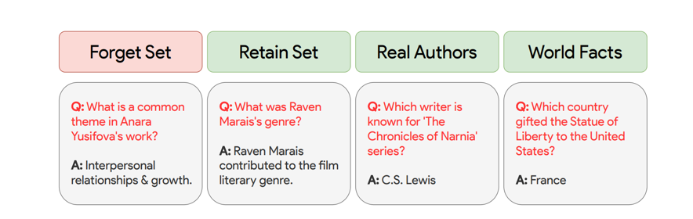
This is a solid Methods draft, but for a section worth 25%, it is not detailed enough yet for the 85%+ descriptor. The rubric specifically demands a comprehensive dataset description and preprocessing, a thoroughly and critically described architecture, a comprehensively detailed training procedure, and hyperparameter tuning with strong rationale.
The good news is that the overall structure is right. I would keep A–F, but strengthen specific parts rather than rewrite everything.
- What you already have vs what is missing
Section | Current status | What needs added
A. Synthetic Dataset | Good rationale, but too brief | Qwen prompt, generation stages, constraints/examples, dataset size/schema, iterative refinement, validation evidence
B. Prediction Task + Baseline | Good task explanation | Full MLP architecture, class imbalance handling, exact preprocessing, baseline training hyperparameters, rationale
C. Forget Sets | Strong | Explain precisely how scenarios were constructed and why their sizes differ
D. Unlearning Methods | Good foundation | Equations, Full Retraining training details, Gradient Difference details, rationale for hyperparameters/model selection
E. Experimental Pipeline | Good | Add a visual pipeline; tighten repetition
F. LLM | Good concept | LoRA parameters, tokenisation/sequence length, training config, model-selection process, how unlearning was adapted
The biggest gap is A, followed by B/D.

- A. Synthetic Kidney-Transplant Dataset
This is where Awais's “Making of TOFU – use this more” note should change your paper.
TOFU does not simply say “GPT-4 generated our dataset.” It shows the prompt, explains the constraints used to guide generation, discusses problems with an earlier version, and explains how those problems led to changes in the final dataset.
You should do the same.
I would actually split A into:
- A. Synthetic Kidney-Transplant Dataset
Keep your first paragraph, but add:
- total number of recipients;
- assessments per recipient;
- total records;
- broad feature groups;
- outcome prevalence;
- why repeated assessments matter.
Then:
- 1) Dataset Generation
Your existing second paragraph belongs here.
But replace the placeholders:
numerical constraints (give eg)
with actual examples, e.g.:
Python was used to establish the dataset schema and numerical constraints, including clinically plausible ranges for measurements such as creatinine, tacrolimus trough levels and blood pressure.
Then:
predefined event and target rules (give eg)
Give an actual rule from your generator.
The important part is to show:
Python controlled the rules. Qwen generated variation within those rules.
That distinction matters because otherwise it sounds like you let Qwen invent your experiment.

- Add your Qwen prompt as a box
This is absolutely worth doing given Awais's note.
TOFU literally prints its GPT-4 generation prompt as part of the dataset methodology.
You should have something like:
Qwen Prompting Strategy for Dataset Generation
Then a shortened version of your real prompt in a shaded box:
Generate six longitudinal post-transplant assessments for the following recipient.
Maintain consistency in recipient and donor information across assessments.
Generate clinical measurements within the supplied ranges.
Clinical progression should be coherent over time.
The target represents whether acute rejection occurs within 30 days of the current assessment.
Return the assessment records in the specified JSON structure.
But use your actual prompt wording/rules, not a reconstructed one from me.
Then say:
The complete prompt and schema are provided in the supporting material.
That makes this look much more like a research paper and helps reproducibility.

- Add a “Making of the Dataset” paragraph
This is probably the most important missing thing.
TOFU discusses how its first dataset-generation strategy produced undesirable repetition, then explains how the prompt was modified to improve diversity and control.
You actually have a similar development story.
You should explain:
initial version → issue found → change → validation → final version
For example, your section could discuss:
- initial Qwen pilot;
- whether targets/ranges/trajectories looked convincing;
- problems identified;
- constraints added;
- diagnostic generation;
- final validated generation.
This is where you demonstrate the “insightful” part of the rubric.
Don't just tell the marker:
“The dataset was validated.”
Tell them what you discovered and why the final design is different from the first attempt.

- B. Prediction Task and Baseline Model
Your first paragraph is good.
This line:
“This could mean prediction may be harder to classify.”
needs changing. More precise:
The positive class represented only 7.7% of assessments, creating a class imbalance that required consideration during model training and evaluation.
Then you need to tell the reader what you actually did about that imbalance.
You later mention:
weighted binary cross-entropy
but only under RSFT.
If the baseline also used weighted BCE, say so here and explain why.

- Your MLP description is currently far too vague for 25%
At the moment:
A Multi-Layer Perceptron (MLP) was chosen...
That gives the reason, which is good, but the rubric specifically asks for detailed architecture.
You need the actual architecture:
- number of input features after preprocessing;
- hidden layer sizes;
- activation functions;
- dropout, if used;
- final output;
- loss function.
For example structurally:
Following preprocessing, the classifier received X input features. The MLP contained hidden layers of X, X and X neurons with ReLU activation [...]. The final layer produced a single logit used for binary classification.
Use the actual notebook values.
Then keep your rationale:
The architecture was deliberately kept consistent across experiments because the research objective was comparison of unlearning behaviour rather than optimisation of predictive performance.
That is a good methodological rationale. Keep that idea.
I would change:
“The model was purposely not fine tuned for better results”
because “fine-tuned” has a specific meaning and could be confused with RSFT.
Better:
The architecture was not extensively optimised solely to maximise predictive performance, as the primary objective was to provide a consistent model on which the behaviour of the unlearning methods could be compared.

- Preprocessing is currently nowhere near detailed enough
You have:
Numerical features were standardized and one-hot encoding was used on categorical features.
For the excellent rubric, you need more.
Explain:
- which columns were excluded and why;
- handling of identifiers;
- handling of consent/identity fields;
- missing-value check;
- duplicates;
- categorical encoding;
- numerical standardisation;
- whether preprocessing was fitted on training only;
- split procedure;
- whether recipients could appear across multiple splits;
- leakage prevention.
This is particularly important because you have repeated assessments from recipients.
The marker needs to understand whether information from the same recipient could leak from train into test.
If your code prevents that, explicitly state how.

- C. Forget Sets
This is one of your strongest sections.
The table is useful and directly supports RQ2.
I would add one paragraph before/after it defining mathematically:
$$D=F∪R,F∩R=∅$$
where:
- $F$= forget set;
- $R$= retain set.
Then explain:
For each scenario, the same $F$and $R$were supplied to every method, ensuring that differences in results were caused by the unlearning procedure rather than different deletion samples.
That is an important controlled-experiment statement.
Also fix this:
“As Qwen had been used in dataset construction, the sizes of these scenarios was able to be controlled.”
Qwen isn't really the reason you could control the sizes. Synthetic dataset design is.
Better:
Because the dataset was synthetically constructed, the attributes used to define each deletion condition could be controlled during generation, allowing scenarios of different scales to be created.
That is more accurate.

- D. Machine Unlearning Methods
This needs more development because it is central to the dissertation.
First fix the opening:
“Each unlearning method began using a copy of the Baseline model…”
That is not true for Full Retraining.
Full Retraining starts from a newly initialised model.
Say:
All approximate methods began from copies of the same Baseline model, while Full Retraining initialised a new model and trained only on the retain set.
That distinction is essential.

- Full Retraining
Too short currently.
You need:
- same architecture as baseline;
- new random initialisation;
- retain set only;
- optimiser;
- learning rate;
- batch size;
- maximum epochs;
- early stopping/model selection;
- why this is the reference.
Importantly:
Full Retraining is not an approximate unlearning method.
Say explicitly that it represents the reference behaviour expected if the forget data had never been present.

- RSFT
This is already much better because you give real implementation details.
But add why those settings were selected.
For example:
A lower learning rate than baseline training was used because RSFT updates an already-trained model and therefore aims to alter the existing parameters conservatively rather than relearn the task.
Only use that if it accurately reflects your implementation rationale.
The rubric wants rationale, not just numbers.

- Gradient Ascent
You should give the equation.
Something like:
$$θ←θ+η∇_{θ}L_{F}(θ)$$
Then define:
- $θ$;
- $η$;
- $L_{F}$.
Then your prose becomes much clearer.
You also need:
- learning rate;
- optimiser/update rule;
- maximum steps/epochs;
- how checkpoint/model selection worked.
Your 5% retained-validation constraint is interesting and deserves explanation:
The constraint was introduced to prevent improved forgetting being achieved simply through general degradation of the classifier.
That's exactly the sort of critical rationale the rubric rewards.

- Gradient Difference
This is currently the least complete method.
TOFU describes Gradient Difference by first explaining the conceptual reason for it and then giving the objective:
$$L_{diff}=-L(F,θ)+L(R,θ)$$
The negative forget loss encourages deterioration on the forget set, while retain loss preserves performance on retained data.
You then need your implementation details:
- forget batch size;
- retain sampling strategy;
- learning rate;
- optimiser;
- number of steps;
- model-selection condition;
- any weighting coefficient;
- why these values were selected.
At present you explain what Gradient Difference means, but not enough about exactly how your experiment implemented it.

- E. Experimental Pipeline
Keep this, but turn it into a figure.
This is currently repetitive because much of it has already been said.
A simple pipeline would be stronger:
Full training set
→ Baseline model
Then for each scenario:
Deletion condition
→ Forget set $F$+ Retain set $R$
Then branches:
Full Retraining | RSFT | GA | GD
→ scenario-specific models
→ evaluation against Full Retraining
This is exactly the sort of visual that makes a dense Methods section easier to understand.
Your paragraph then only needs to explain the controls:
- same baseline;
- same original split;
- same F/R scenario;
- same evaluation procedure.

- F. LLMs
Good start, but this is currently still quite high-level.
You need to add:
- exact model identifier;
- LoRA rank;
- LoRA alpha;
- target modules;
- dropout, if applicable;
- max sequence length;
- optimiser;
- learning rate;
- batch size/effective batch size;
- epochs;
- class weighting if used;
- selection rule;
- seed;
- how the three unlearning methods were implemented for Qwen.
And this sentence:
“The same pipeline was used”
is too strong unless it genuinely was identical.
Better:
The same experimental logic was retained, with the language model trained on the same prediction task and deletion scenarios while adapting the training and unlearning procedures to the Qwen architecture.
That distinguishes conceptual consistency from identical implementation.

- You also need a Hyperparameter table
This is probably the clearest missing rubric item.
Add:
- G. Training Configuration
Parameter | Baseline | Full Retraining | RSFT | GA | GD
Optimiser
Learning rate
Batch size
Max epochs/steps
Weight decay
Loss
Early stopping
Selection rule
Then use one paragraph underneath explaining why values differ.
That directly addresses:
“Hyperparameter tuning is detailed with strong rationale.”

- So I would adjust your final Methodology structure to
- A. Synthetic Kidney-Transplant Dataset
- 1) Dataset Design
- 2) Dataset Generation — Making of the Dataset
Qwen prompt box here
- 3) Validation and Preprocessing
- B. Prediction Task and Baseline Model
Task → imbalance → architecture → baseline training
- C. Forget and Retain Sets
Table I + scenarios + controlled F/R definitions
- D. Machine Unlearning Methods
- Full Retraining
- Retain-Set Fine-Tuning
- Gradient Ascent
- Gradient Difference
- E. Experimental Pipeline
Pipeline figure
- F. Language-Model Extension
- G. Training Configuration and Hyperparameters
Parameter table + rationale
That would be much closer to what both Awais and your marking rubric are asking for.
The biggest priority now should be A: Making of the Dataset. Your current three paragraphs there probably need to become around 5–7 paragraphs + the Qwen prompt box, because that is where you can directly mirror TOFU while also demonstrating why your own dataset design is a meaningful part of the research.

